**Mini Project Report on**



**CLOUD BASED ONLINE BLOOD BANKING SYSTEM**



**Submitted in partial fulfilment of the requirement for the award of the degree of**

**BACHELOR OF TECHNOLOGY**

**IN**

**COMPUTER SCIENCE & ENGINEERING**

**Submitted by:**

**Student Name**  **University Roll No.**

**Harshit Dutt Tyagi 2018825**

***Under the Mentorship of***

**Dr. Prakash Srivastava**

**Associate Professor**



**Department of Computer Science and Engineering**

**Graphic Era (Deemed to be University)**

**Dehradun, Uttarakhand**

**January-2024**



**CANDIDATE’S DECLARATION**

I hereby certify that the work which is being presented in the project report entitled **“Cloud Based Online Blood Banking System”** in partial fulfillment of the requirements for the award of the Degree of Bachelor of Technology in Computer Science and Engineeringof the Graphic Era (Deemed to be University), Dehradun shall be carried out by the under the mentorship of **Dr. Prakash Srivastava, Professor**, Department of Computer Science and Engineering, Graphic Era (Deemed to be University), Dehradun.

Harshit Dutt Tyagi 2018825 

**Table of Contents**

|  |  |  |
| --- | --- | --- |
| **Chapter No.** | **Description** | **Page No.** |
| Chapter 1 | Introduction | **1-2** |
| Chapter 2 | Literature Survey | **3-4** |
| Chapter 3 | Methodology | **5-6** |
| Chapter 4 | Result and Discussion | **7-11** |
| Chapter 5 | Conclusion and Future Work | **12** |
|  | References | **13** |

**Chapter 1**

**Introduction**

* 1. **Problem Statement:-**

Entering the details about the blood groups, members, name, date of birth etc. And tracking the database is complicated when the details are maintained. This makes the maintenance of schedule erroneous**.** The major problem in Blood Donation systems was that, they don’t follow the actual needs of users. Traditional blood donation systems were developed by 1 or 2 perspective. There was shortage and sometimes unavailability of rare blood groups due to less modules i.e. patient and donors.

* 1. **What is the Problem?**
* The major problem in Blood Donation systems was that, they don’t follow the actual needs of users.
* Traditional blood donation systems were developed by 1 or 2 perspective.
* There was shortage and sometimes unavailability of rare blood groups due to less modules i.e. patient and donors.
* In this way we realize that the new system is required and will certainly improve the performance of the exiting system over the exiting paper based system.

1. Design the system to develop the alternative computer based system.
2. To understand the user characteristic.
3. Design a system for a particular types of user.
   1. **Limitations**

* There is no communication between donor and patient.
* It lacks of data security.
* Availability issue among Hospitals.
* Patient can’t get any message or email for blood.

* 1. **Objective**
* The main aim of this project is to save lives of people by providing blood.
* My project for Online Blood Banking System is a Website.
* This website reduces the time to a greater extent that is searching for the required blood among users and Hospitals.
* Thus this application provides the required information in less time and also helps in quicker decision making.
* The data are maintained in the database named as “bloodbank”. New blood details are entered by users into the project to manage blood availability in hospitals. Blood donor /User details are entered and maintained in the database.
* The Software is designed to handle the blood data, Search, Request, Accept the details when required.
* It also helps to register the details of donors, blood collection details.
* The website is designed in such a manner that it can suit the needs of all the blood requirements in the course of future.
* It will help us to find the Blood group with its most efficient time to take care of the blood and it is more easy to hand over the blood to the hospital to help people to get blood on time.
  1. **Scope**
* The purpose of the online system is to create convenient and easy-to-use online system for Users and Hospitals, trying to get or donate blood. The system is based on a relational database.
* The specification builds on the experience of users of IT technology in blood transfusion that is currently available and informs both Connecting for Health (CFH) and commercial companies producing both hardware and software.

**Chapter 2**

**Literature Survey**

**2.1 History**

* “Blood Bank Management Information System in India” by Vikas Kulshreshtha and Dr. Sharad Maheshwari introduces the evaluation of most important features, merits, and demerits furnished through the present Web-based Information System for Blood Banks. This have a look at describes the contrast of the numerous current gadget and offers a few greater thoughts for enhancing the present gadget.
* “The Benefits of Management Information System in Blood Bank” by Vikas Kulshreshtha and Dr. Sharad Maheshwari describes the advantages of control records structures in blood banks. The paper is centered on the blood financial institution control records system. It discusses the beneficiaries of the blood financial institution control records system.

Between this point and the present, there have been numerous further advancements in this system by various peoples , the most significant of which are:

* “Android Blood Bank” by Prof. Snigdha, Pratiksha Lokhande, Siddhi Kasar and Pranita More describes the android software which well timed updates the records concerning donors where the admin accesses the entire records approximately blood financial institution control system. The app presents a listing of blood banks relying upon the user’s location.
* In “ Optimization of Blood Donor Information and Management System by Technopedia” by P. Priya and V. Saranya, It provides blood donors with an efficient and reliable information and management system based on GIS, which has been integrated into the Android mobile application. The services provided by the proposed system are critical to the health sector, and to their health, because blood quality is viewed from the perspective of patient safety through the systematic processes performed by the blood management system.
* “A Study on Blood Bank Management System” by A. Clemen Teena, K. Sankar, and S. Kannan is an information control machine that facilitates to manipulate the facts of donors and sufferers at a blood financial institution. The machine will permit the legal blood financial institution officer to login the usage of a mystery password and easily manipulate the facts of the blood donors and the sufferers in need of blood.
* In “MBB: A Life-Saving Application” by Narendra Gupta, Ramakant Gawande, and Nikhil Thengadi, they have proposed a machine so that it will hyperlink all donors. The machine will help to control the blood transfusion service and create a database to maintain records on shares of blood in every place as records on donors in every city. Moreover, human beings will be capable of see which sufferers want blood components thru the application. They will be able to check in as donors and as a result acquire a request from their nearby customers who desires blood to donate blood in instances of want.

**2.2 Software System Attributes Followed In These Advancements**

**2.2.1 Usability**

* The system is fully usable and does not require any pre-specified constraint to work properly.

**2.2.2 Efficiency**

* Hardware should me min. Pentium with 196 MB RAM (Fully efficient in the environments having less memory available and a reasonable speed of execution).

**2.2.3 Maintainability**

* In case of any change in policies and rule of the institution using the system, required changes will be made to the module written by developer.

**2.2.4 Security**

* Only the super user can enter the system to use it and manage all the databases.

**2.2.5 Performance**

* System itself is quiet fast and System gives accurate result without any errors.

**Chapter 3**

**Methodology**

This project is created for two users: Donors/Receivers and Hospitals/Clinics(Doctors), where a Hospital user can add blood sample to their blood bank, request for blood, check status of their request, update their details, etc. The donor/receiver can also do the same.

**3.1 Technologies Used**

1. **Frontend:** HTML, CSS, Bootstrap, JavaScript.
2. **Backend:** Database-MySQL.
3. **Frontend-Backend connection:** PHP.

**3.2 System Requirements**

1. Xampp Software
2. Sublime text/Visual studio code software or any software supporting PHP,HTML, CSS.
3. Java Jdk

**3.3 Project Management**

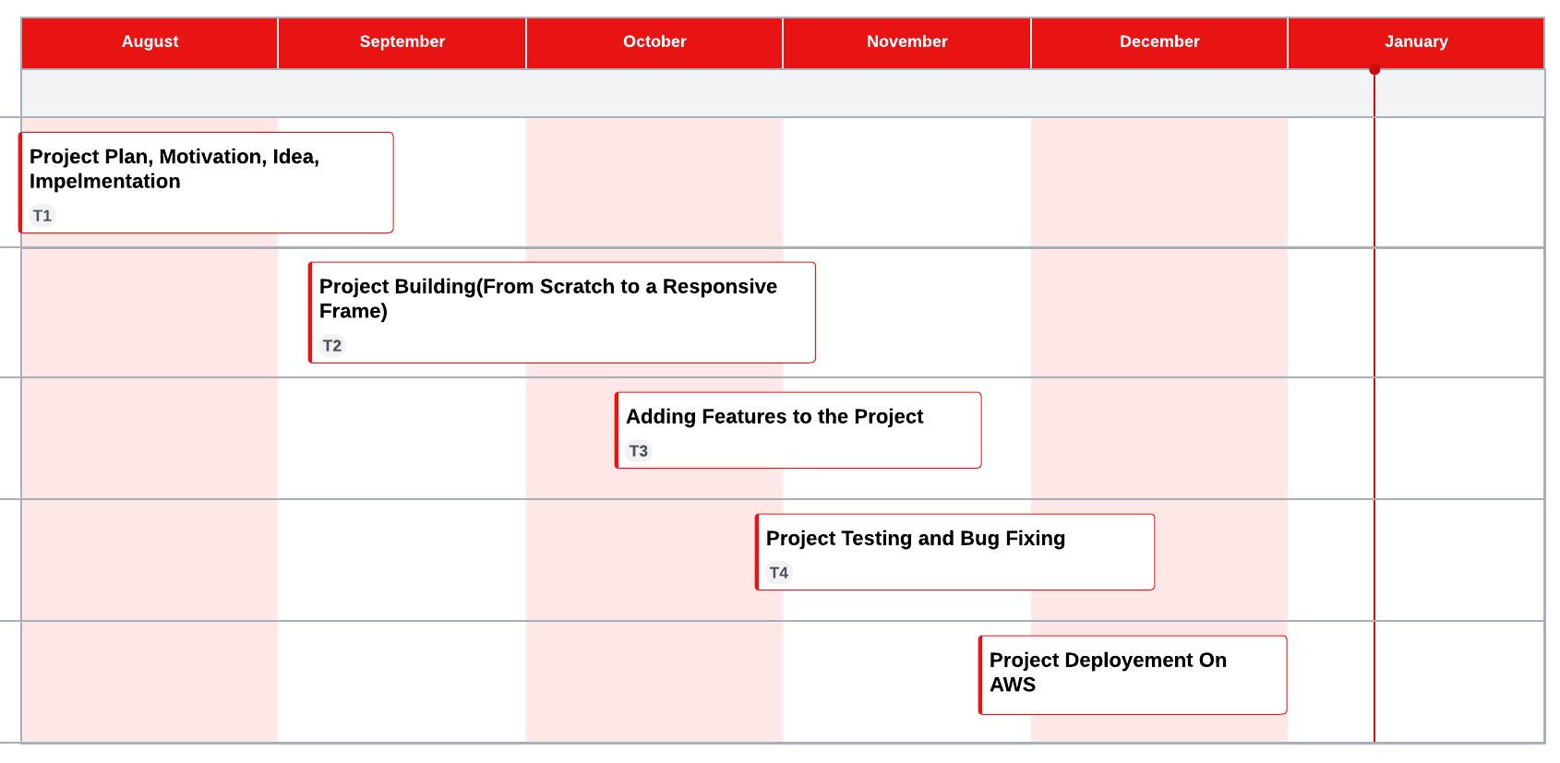

**Figure 3.3.1** Gantt Chart

**3.4 System Diagrams**

**Figure 3.4.1 Data Flow Diagram - 1**

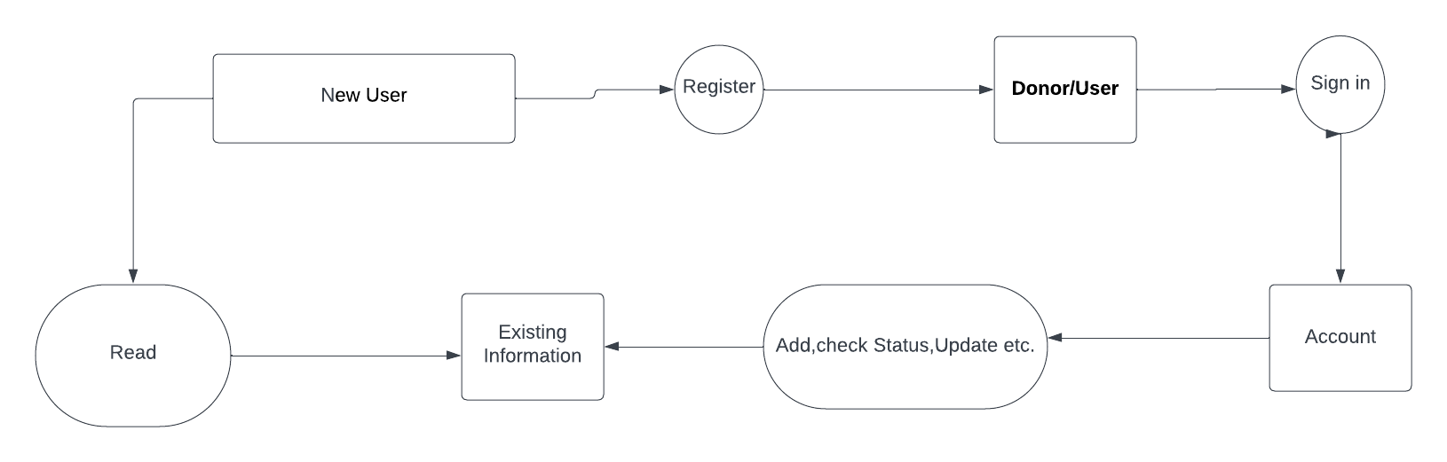

**Figure 3.4.2 Data Flow Diagram - 2**

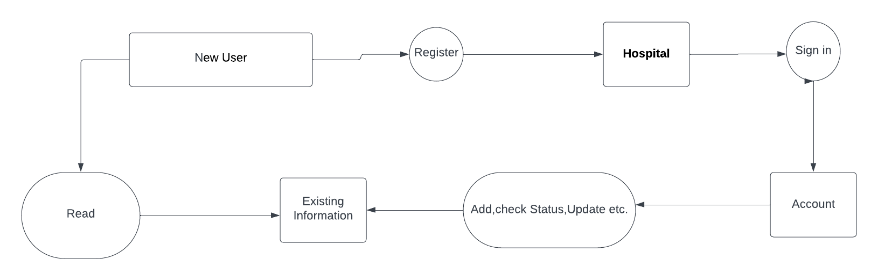

**Figure 3.4.3 Data Flow Diagram - 3**

**Chapter 4**

**Result and Discussion**

* **Home Page**

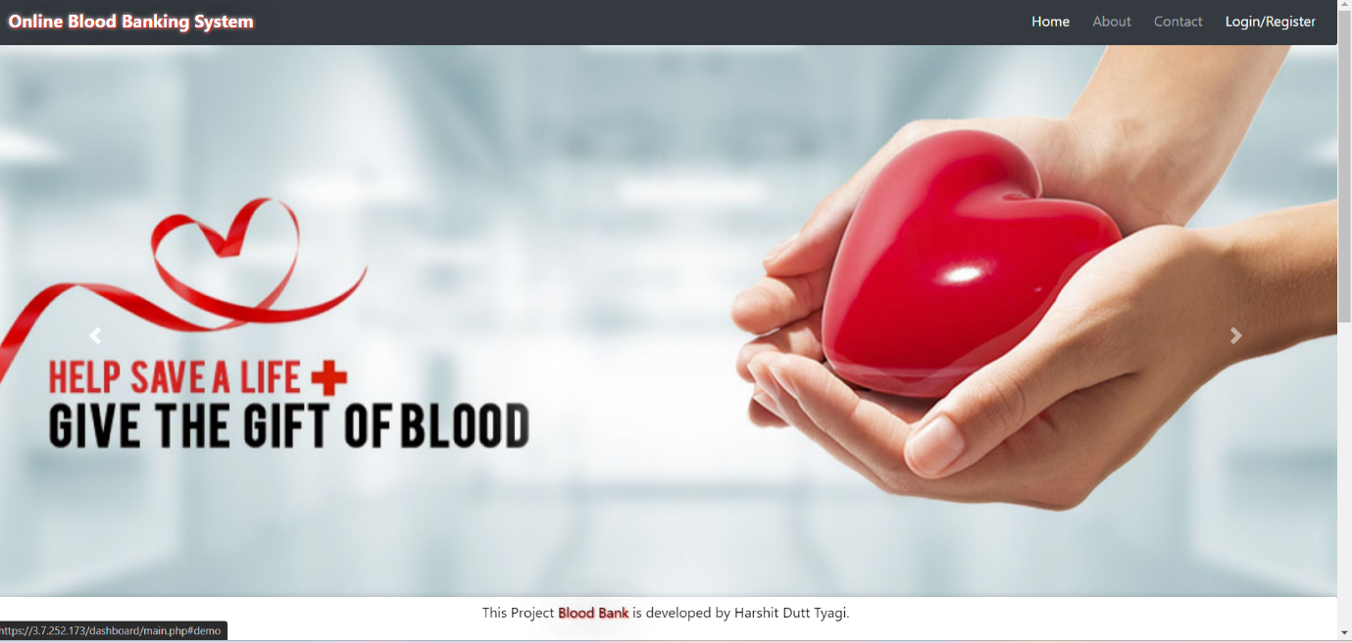

* **Login/Register Page**

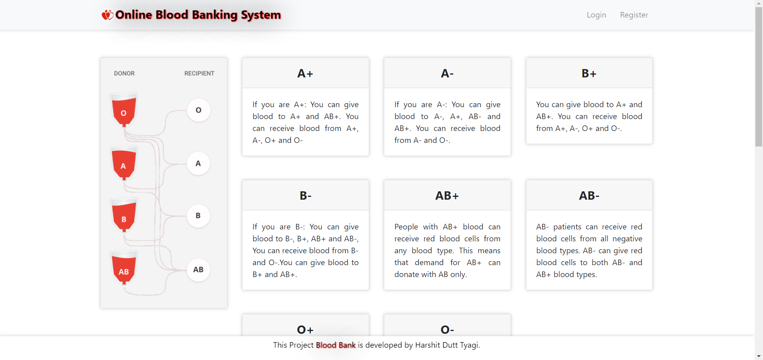

* **Registration Page**

* **Login Page**

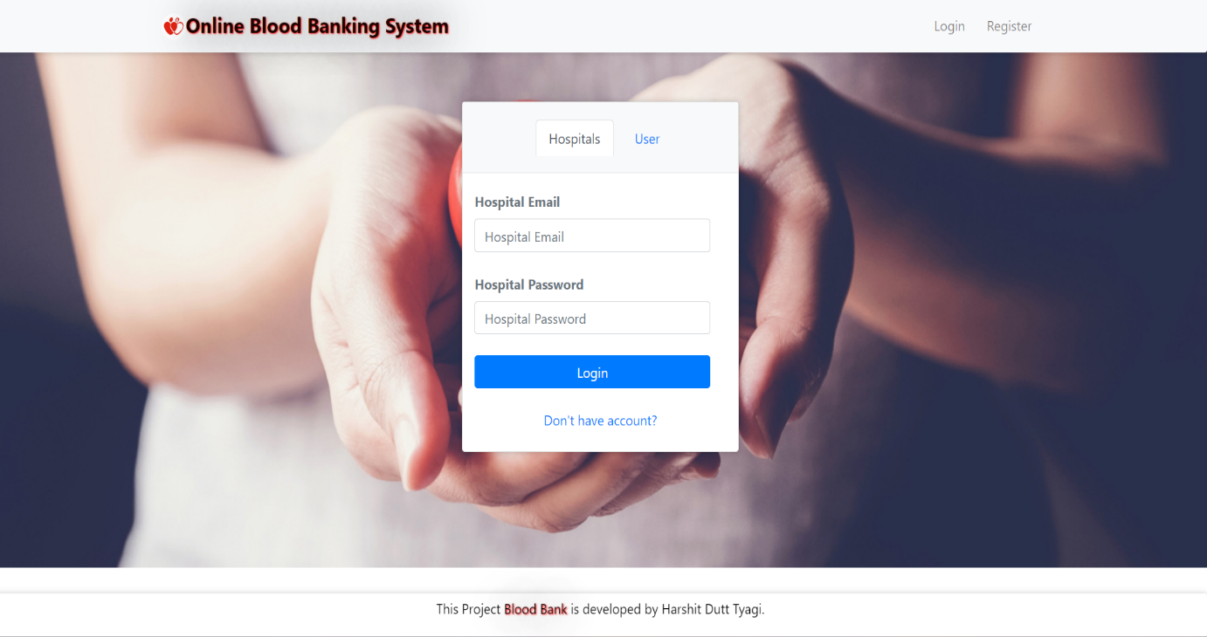

* **After sign in(Hospital)**

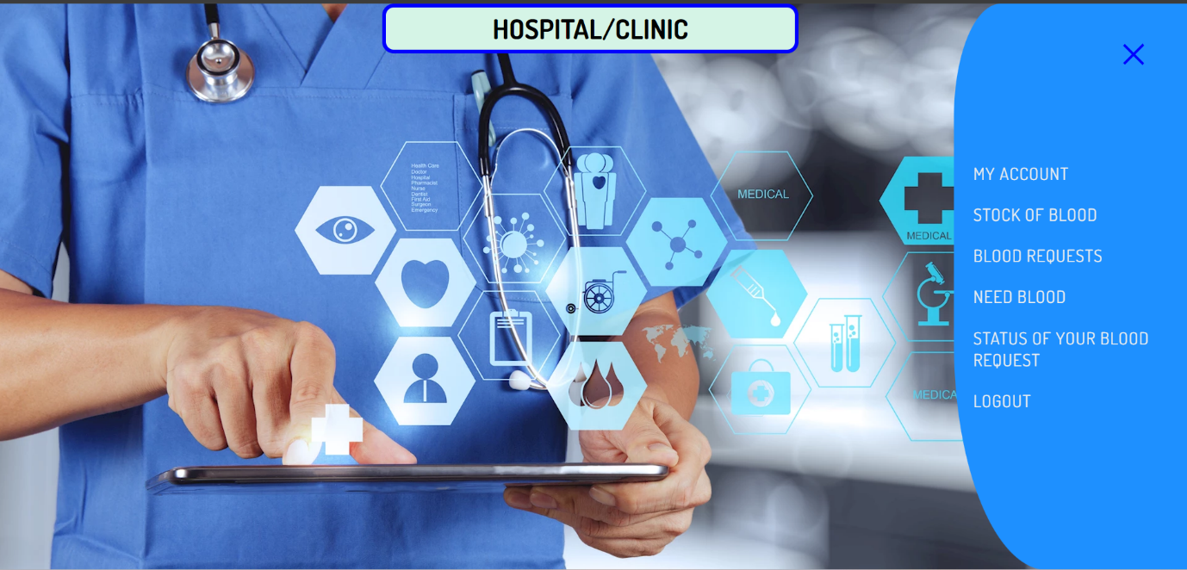

* **After sign in(User)**

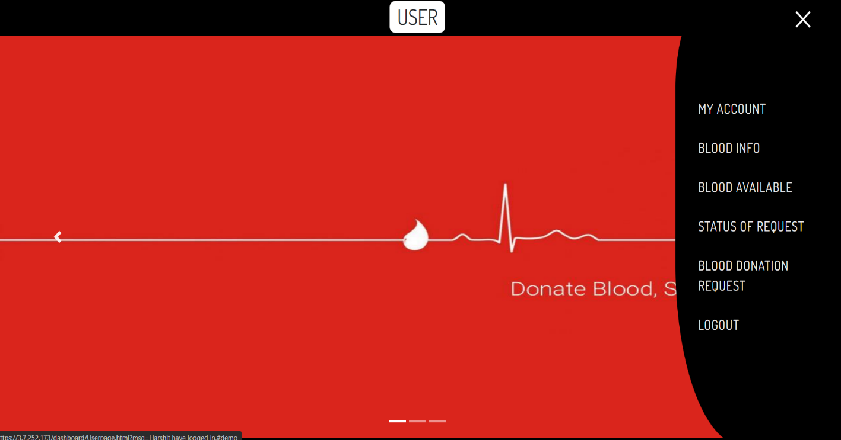

* **Dashboard For Hospital**

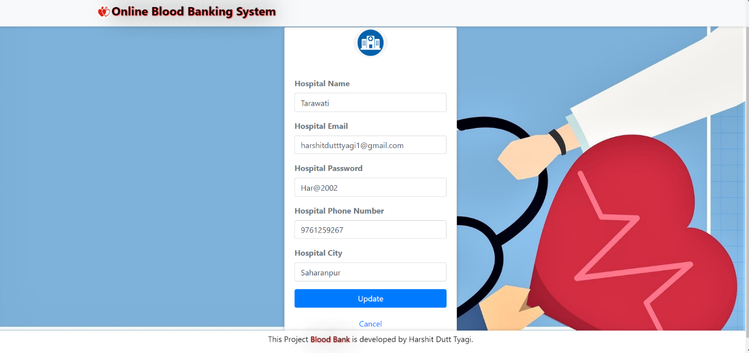

* **Dashboard For User**

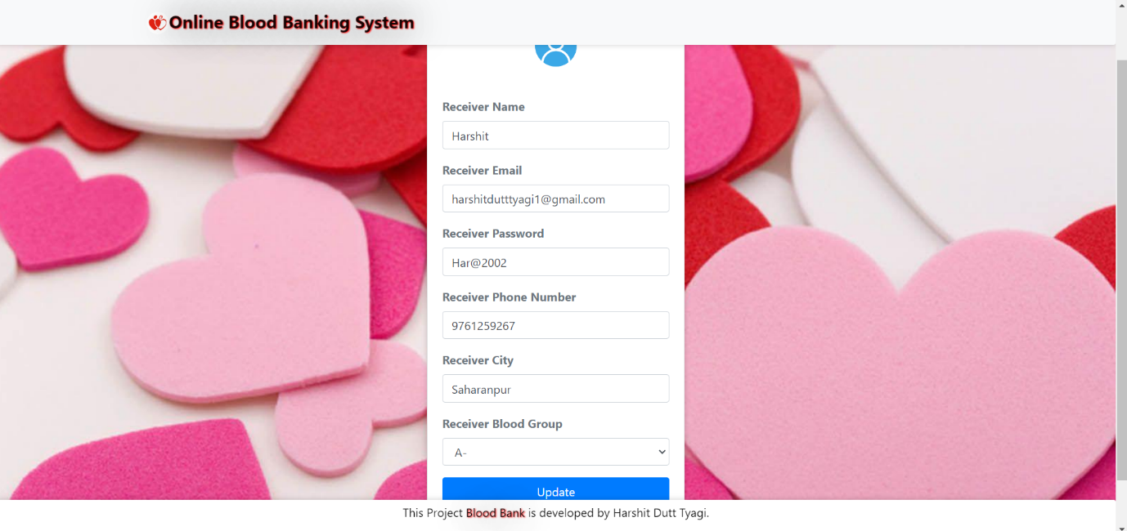

* **Search Blood**

* **Blood Request**

**Chapter 5**

**Conclusion and Future Work**

**5.1 Conclusion**

* This report presents The Blood Donation related issues.
* The objectives of project is implemented by implementing the different plans such as time estimated through Gantt chart, work background, flowchart etc...
* Online blood Banking system make work easy, and ensures fast retrieval of data when needed.

**5.2 Future Work**

1. I will try to implement a machine learning model in this project to classify all the blood groups available with hospitals.
2. Also I will try to integrate GIS system in it for the location of Hospital and Donor.
3. Can implement Mobilink Paging Services . Mobilink's Paging Service aids those in urgent need of blood. Users provide details through a dedicated number, and Mobilink broadcasts the request to subscribers' pagers, displaying vital information like blood group, hospital, and contact details for quick donor response.
4. Can give rewards on blood donation by collaborating with blood banks to users.

**References**

[1] “Blood Bank Management Information System in India” by 1, Vikas Kulshreshtha, 2, Dr. Sharad Maheshwari 1, Research Scholar, 2, Associate Professor 2 1, Singhania University, Jhunjhunu, Rajasthan, India 2, Government Engineering College Jhalawar, Rajasthan, India

[2] “Benefits of the Management Information System in Blood Bank” by 1, Vikas Kulshreshtha, 2, Dr. Sharad Maheshwari 1, Research Scholar, 2, Associate Professor 2 1, Singhania University, Jhunjhunu, Rajasthan, India 2, Government Engineering College Jhalawar, Rajasthan, India

[3] “Android Blood Bank” by Prof. Snigdha1, Varsha Anabhavane2, Pratiksha lokhande3, Siddhi Kasar4, Pranita More5 Lecturer, Information Technology, Atharva College of Engineering, Mumbai, India 1 Student, Information Technology, Atharva College of Engineering, Mumbai, India 2,3,4,5 [4]. The Optimization of Blood Donors Information and Management System by Technopedia P. Priya1, V. Saranya2, S. Shabana3, Kavitha Subramani4 Branch of Computer Science and Engineering, Panimalar Engineering

[4]“A Study on Blood Bank Management System” by A. Clemen Teena, K. Sankar and S. Kannan, Department of MCA, Bharath University, Selaiyur, Chennai-73, Tamil Nadu, India

[5] “MBB: Life-Saving Application” by Narendra Gupta1, Ramakant Gawande2 and Nikhil Thengadi3 1, 2, 3 Final Year, CSE Dept., DIET, Yavatmal, India.